CSCI 6146

Group Project-Phrase I

Group Five

2/5/2014

This document describes a simple Java-based CPU simulator developed by Group Five. This CPU simulator provides an interface that has all functions mentioned by the instructor.

By double clicking the .jar file and run the controlpanel.java file, users are able to see the simulator screen like the screenshot below.

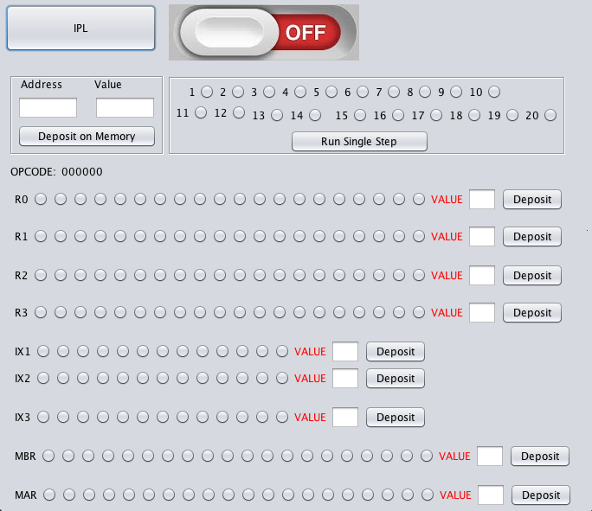

By clicking the IPL, the light turns on.



The first step is to initial the memory by providing any decimal format number to the Address and Value and clicking the Deposit on Memory button.

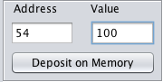 (e.g. Input one hundred to Address 54)

To actually execute code, users should select the switches as the command and click Run Single Step button to run the simulator.

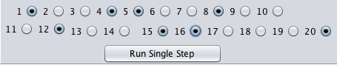

The basic instruction format is shown below:

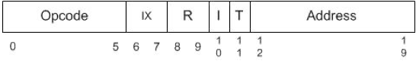

The initial number of switch is ‘0’. The number will become ‘1’ after the user clicks the switch. The first six digits are OPCODE that determine which instruction the program will execute. The next two digits identify the index register and specify indirect addressing. The number of index register is identified as “01”, “10” or “11”. The ninth and tenth switch specifies one of the four General Purpose Registers. The eleventh switch identifies whether it is an indirect addressing and the twelfth switch specifies whether the instruction is traced. The rest of the switches are identified as address.

After clicking the button “Run Single Step”, the result will be displayed on the output window.

The textbox and the “Deposit” button are used for testing. An example is as followed.

Mac OS:Users:macbookpro:Desktop:6.png

The user will get a final result as the screenshot below. The command line is: LDA, 0, 3,159, [, I]

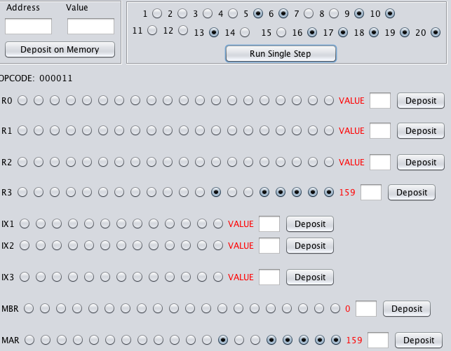

The chart below is a reference of the OPCODE.

|  |  |  |  |  |  |  |  |  |
| --- | --- | --- | --- | --- | --- | --- | --- | --- |
| LDR | STR | LDA | LDX | STX | AMR | SMR | AIR | SIR |
| 000001 | 0000010 | 000011 | 101001 | 101010 | 000100 | 000101 | 000110 | 000111 |